HEdClass Report
System Overview

Repository & Access Details
Repository:
https://gitlab.eeecs.qub.ac.uk/40365038/hedclass

Setup Instructions:
- Clone the repository:
  - https://gitlab.eeecs.qub.ac.uk/40365038/hedclass
- Install dependencies:
  - npm install
- Configure database connection based on XAMPP/MAMP (set to XAMPP by default)
- Start application
  - npx nodemon
- Access in browser
  - http://localhost:4000

Database Setup:
Import provided seeder file within:
/src/seeder/seed.sql

Legacy Users:
Classification Officer:
Role | Email | Password
Classification Officer | officer1@hedclass.com | password123
Admin | admin@hedclass.com | password123

Implemented Functions
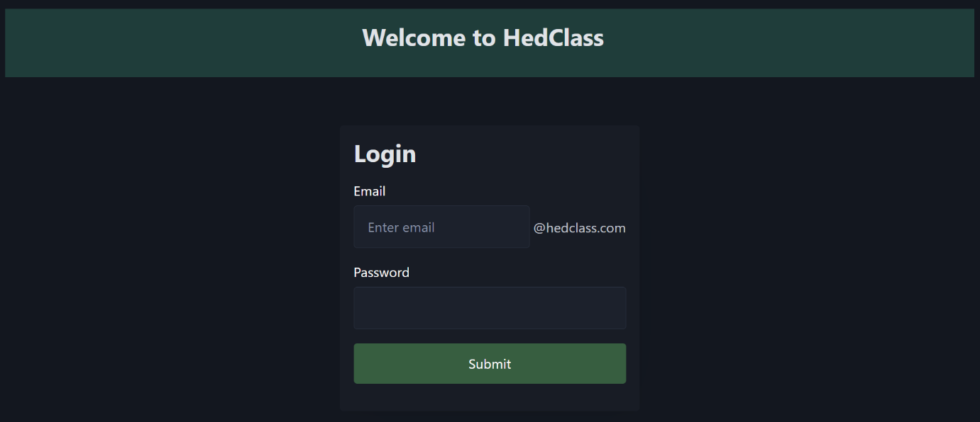
Login Page
Figure 1. Login Page (“/”)

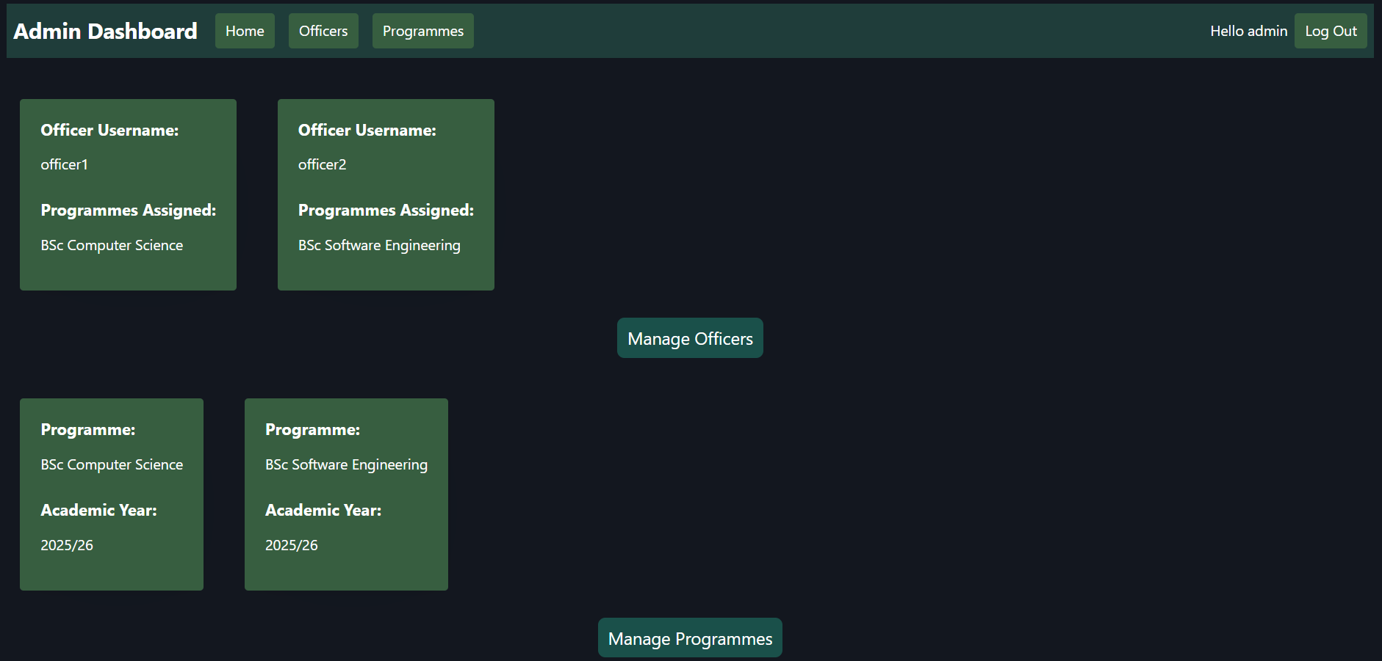
Admin Dashboard
Figure 2. Admin Dashboard (“/admin”)
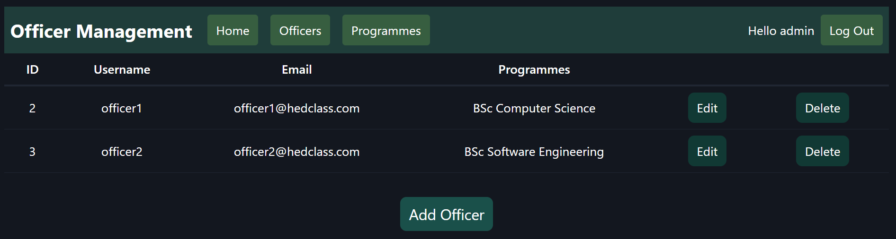
Manage Officers
Figure 3. Officer Management page (“/admin/officers”)
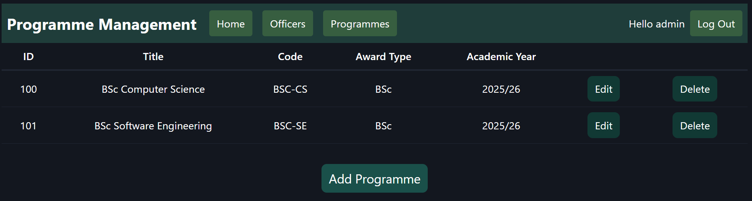
Manage Programmes
Figure 4. Programme Management page (“/admin/programmes”)

Officer Dashboard
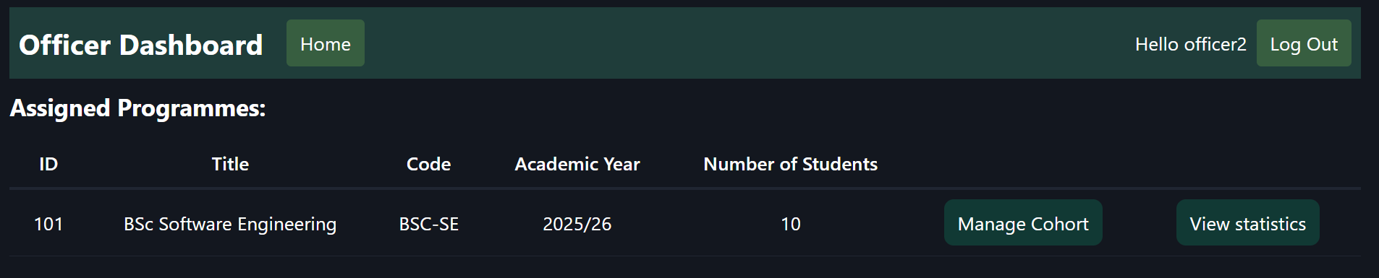
Figure 5. Officer Dashboard (“/officer”)

Student Management
Student Results
Programme Statistics

